**UNIVERSITY OF PETROLEUM & ENERGY STUDIES**

**Dehradun**

**CONTINOUS INTEGRATION**

**AND**

**CONTINOUS DELIVERY**

**Experiment**

**Name: Rithik Choudhary**

**Course: B. TECH CSE DevOps (2018-22)**

**Roll no.: R171218084**

**Sapid: 500069261**

**Experiment-3**

**Jenkins Integration with GitHub and Maven**

**Step-1: Open Command line and type the command to run the Jenkins.**

**>systemctl start jenkins**

**Type localhost:8080 in the browser to run the Jenkins and login.**

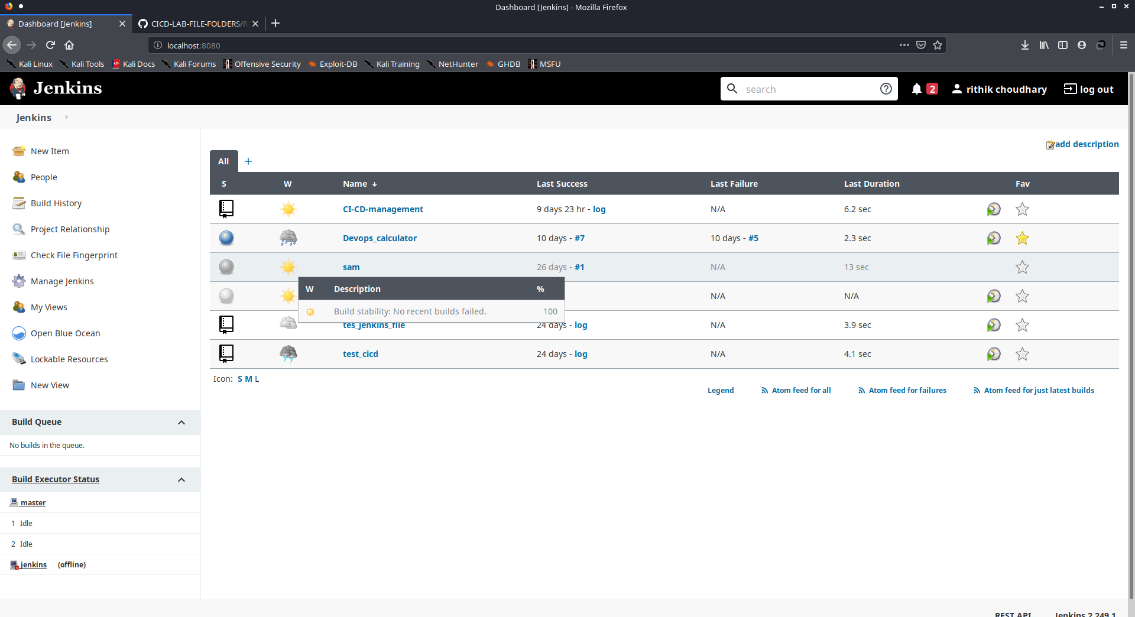

**Step-2: Click on the new item to create a new freestyle project and specify the name and click ok.**

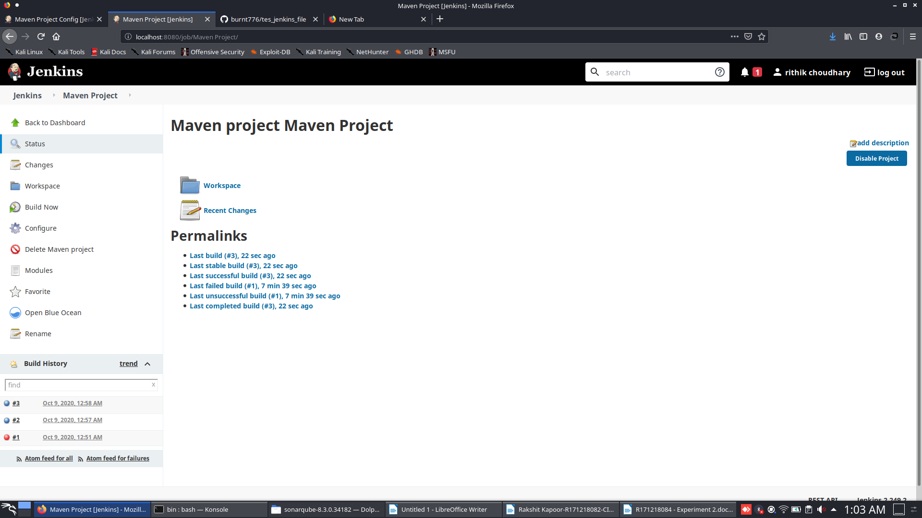

**Step-4: Click on save button and your Jenkins is integrated with GitHub and maven for this repository. Click on Build now to check the code and the changes you made.**

